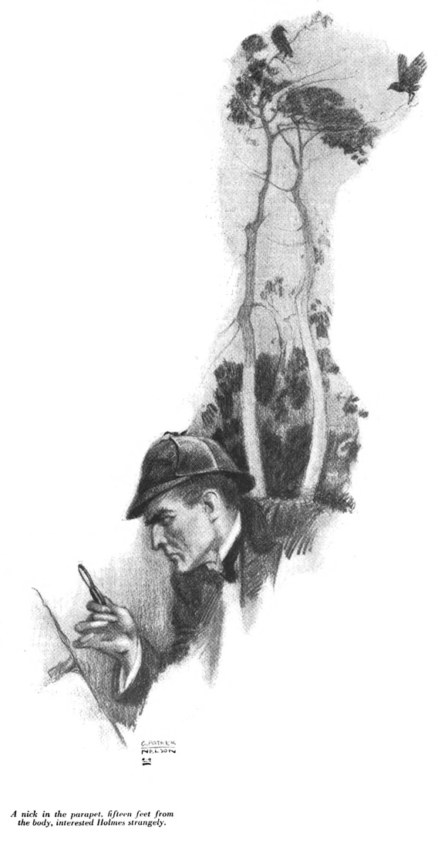

The Hudson Valley Sciontists
will dine and discuss

The Problem of Thor Bridge

Sunday, October 13, 2019
At Vassar College Alumnae House

6:00 cocktails (cash bar), 6:30 dinner

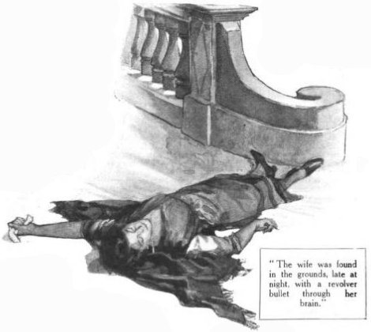
RSVP with check ($44)
Lou and Candy Lewis
2 Loockerman Avenue,
Poughkeepsie, NY 12601
Phone (845) 471-0296
Email: CLewis1880@aol.com

JCR/2019

