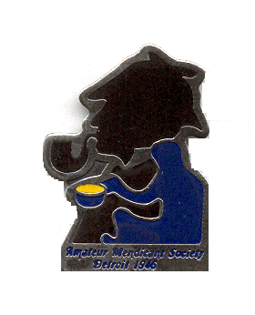Amateur Mendicant Society

Of Detroit, Established in 1946

Gasogene: Tidewaiter:

John Kramb (248) 470-2342 Chris Jeryan (248) 854-2180

Commissionaire: Tantalus:

Chris Music (248) 922-9739 Rob Musial (313) 885-9153

**“… the best & wisest man whom I have ever known.”**

*-- Dr. John Watson about Sherlock Holmes.*

We cordially invite you to join with like-minded friends to celebrate that “best and wisest man” with an evening of fine food and conversation at the fall meeting of the Amateur Mendicant Society of Detroit.

**Saturday, October 19, 2024**

**6:00 p.m.**

**The Commonwealth Club**

**30088 Dequindre, Warren Club phone: (586) 751-9560**

Our assigned story is “The Final Problem,” in which the criminal mastermind, Prof. Moriarty, tries to have Holmes killed and finally pursues Watson and Holmes to Europe -- and a final confrontation at the Reichenbach Falls in Switzerland.

Besides the Mendicant History minute and a consideration of the story’s talking points, there will be two presentations, the first by Glenn Walters on “The Doctors of the Canon” and the second, by Jerry Kelly, on “Everything You Didn’t Know About Sherlock Holmes.”

Also included will be the usual toasts organized by Chris Music plus prizes and a book sale from the extensive collections of Dr. Edward Stein and Jerry Alvin, to benefit the Mendicant treasury.

To attend, please make checks for $31 to: **Amateur Mendicant Society of Detroit** and mail to the address below by **FRIDAY, OCTOBER 11.** Or visit PayPal at [amateurmendicantsociety@gmail.com](mailto:amateurmendicantsociety@gmail.com) for instructions.

**AMATEUR MENDICANT SOCIETY OF DETROIT**

**c/o Chris Jeryan**

**22129 Metamora Drive**

**Beverly Hills, MI 48025**

**The buffet includes pasta, chicken and beef entrees, vegetables, a garden salad and dessert plus coffee, tea, and soft drinks. As always, there will also be a cash bar.**

***“Come at once if convenient … if inconvenient, come all the same.”***

***- from “The Adventure of the Creeping Man.”***